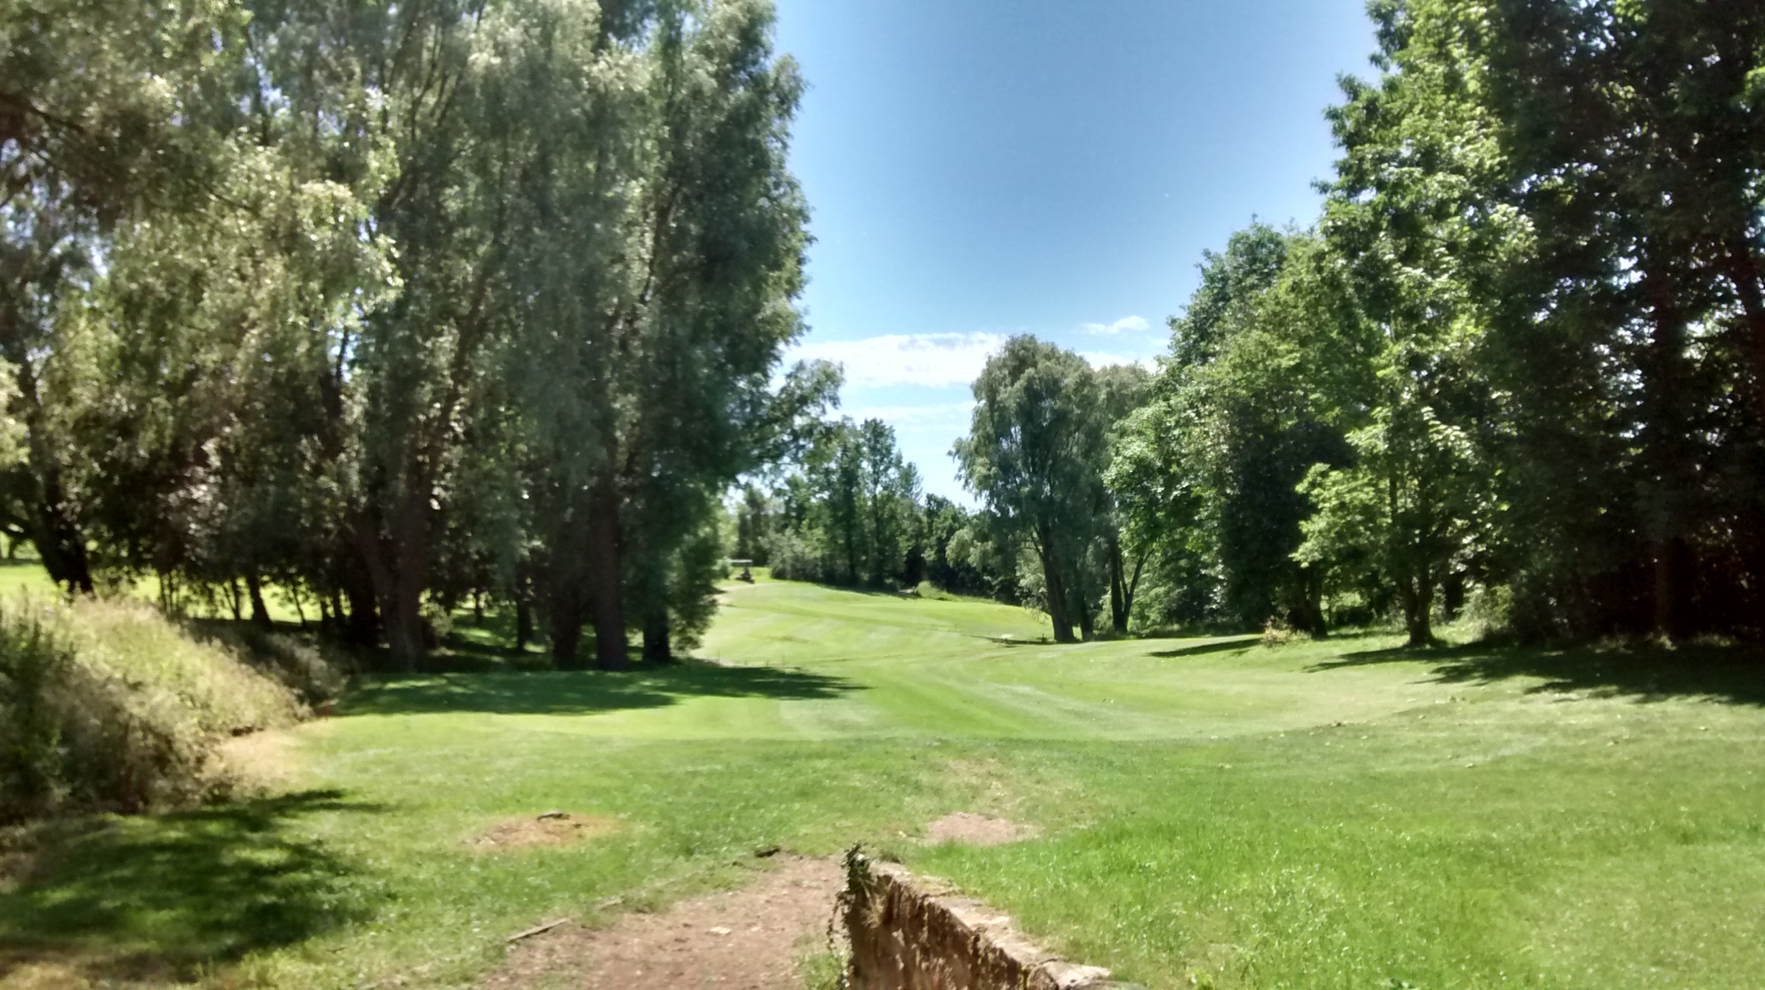


Ladies Open Texas Scramble
Friday 15th June 2018
Application Form
Team to consist of four ladies
10% handicap allowance
4 drives by each player
No more than 2 Shirland members per team
Entry fee £40 per team
(Not refundable but substitutes accepted)
Prizes will be in the form of vouches which can used to purchase item/s from the Shirland professional shop.
There will be no presentation. Contact details must be left with the club on the day of the competition
Food available to order on the day

Handicap certificates required (entrants must have an active handicap)
Forename | Surname | HCP | Club

Preferred tee time: am pm (please tick)

Contact name & address: | Contact Telephone Number: | Contact email address:

Please send completed entry form with cheque made payable to Shirland Golf Club and enclose a stamped self-addressed envelope to: The Secretary, Shirland Golf Club, Lower Delves, Shirland, Alfreton, DE55 6AU or book online at www.Shirlandgolfclub.co.uk
-------------------------------------------------------------------------------------------------------------------------------------
Shirland Golf Club Ladies Open Texas Scramble
Friday 15th June 2018

Received with thanks the sum of £………….. Your tee time is: ……………….

All enquiries to:
The Pro Shop, Shirland Golf Club, Lower Delves, Shirland, Alfreton, DE55 6AU; tel: 01773 834935
Email: office@shirlandgolfclub.co.uk

